ASSIGNMENT NO 13:
1) create a union of two queries that shows the names cities and ratings of all customers those with rating of 200 are greater will also have the words high rating while others will have the words low rating

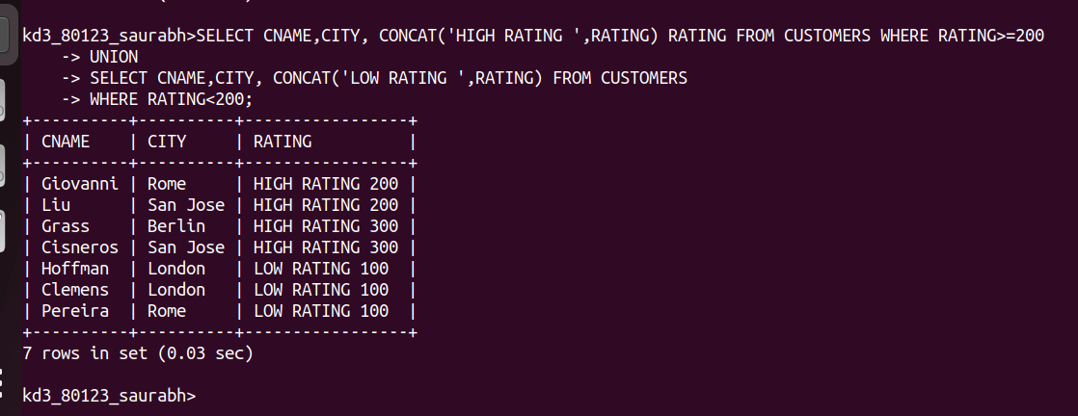
2) write a command that produces the name and number of each persons person and each customer with more than one current order put the result in alphabetical order
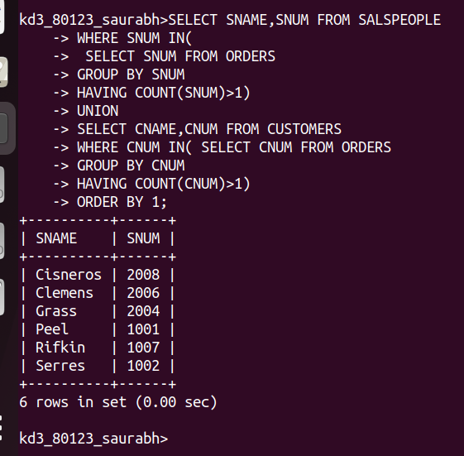
3) form a union of three queries have the first select the snum of sales people in Saint Jose the second the snum of all customer in San Jose and the third the onams of all customers in October 3 1990 written duplicates between the last two queries but eliminate any redencies between either of them and first
